Order Of Service

Singing: Psalm 22—CW page 71

Reading: Psalm 71—The Prayer of an Old Man

Opening Hymn: TLH 41

Reading: Acts 9:19b-25

Request Hymn: CW Supplement 702

Reading: John 19:1-11

Sermon Hymn: TLH 39

Sermon Text: Daniel 5:1-4

A Great Feast

Prayer

The Apostles’ Creed, TLH page 12

Holy Communion

The Lord's Prayer

The Blessing

Closing Hymn: TLH 45

* * * * * * * * * * *

Bible Study: Lambs: Barley
Sheep: Romans 11:1-6
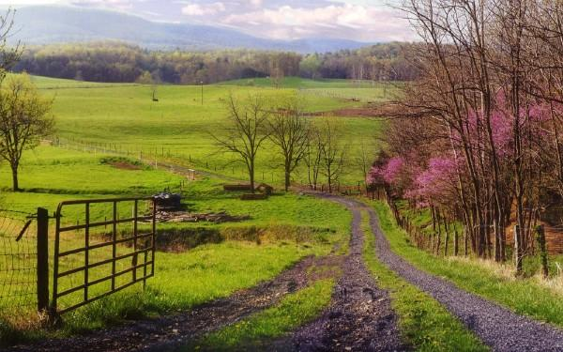

Springtime In The Valley

Water
Of
Life

22 April 2018

W A T E R O F L I F E

Independent Christian Church—Conservative Lutheran Doctrine

Worship Service: 9:30 a.m. Bible Study: 10:45 a.m.

Larry Cooper, Pastor E-Mail address:
111 N. Ridge Road lcooper@wateroflife.cc
Coon Valley, WI 54623 Web Site:
Phone: (608) 452-2105 www.wateroflife.cc

* * * * * * * * * * * * * * * * * * * * * * * * * * *

Sermon Text: Daniel 5:1-4

A Great Feast

* * * * * * * * * * * * * * * * * * * * * * * * * * *

Daniel 5:1 Belshazzar the king made a great feast to a thousand of his lords, and drank wine before the thousand.
:2 Belshazzar, whiles he tasted the wine, commanded to bring the golden and silver vessels which his father Nebuchadnezzar had taken out of the temple which was in Jerusalem; that the king, and his princes, his wives, and his concubines, might drink therein.
:3 Then they brought the golden vessels that were taken out of the temple of the house of God which was at Jerusalem; and the king, and his princes, his wives, and his concubines, drank in them.
:4 They drank wine, and praised the gods of gold, and of silver, of brass, of iron, of wood, and of stone.

Contrast with Jonah 3

Jonah 3:1 And the word of the LORD came unto Jonah the second time, saying,
:2 Arise, go unto Nineveh, that great city, and preach unto it the preaching that I bid thee.
:3 So Jonah arose, and went unto Nineveh, according to the word of the LORD. Now Nineveh was an exceeding great city of three days' journey.
:4 And Jonah began to enter into the city a day's journey, and he cried, and said, Yet forty days, and Nineveh shall be overthrown.
:5 So the people of Nineveh believed God, and proclaimed a fast, and put on sackcloth, from the greatest of them even to the least of them.
:6 For word came unto the king of Nineveh, and he arose from his throne, and he laid his robe from him, and covered him with sackcloth, and sat in ashes.
:7 And he caused it to be proclaimed and published through Nineveh by the decree of the king and his nobles, saying, Let neither man nor beast, herd nor flock, taste any thing: let them not feed, nor drink water:
:8 But let man and beast be covered with sackcloth, and cry mightily unto God: yea, let them turn every one from his evil way, and from the violence that is in their hands.
:9 Who can tell if God will turn and repent, and turn away from his fierce anger, that we perish not?
:10 And God saw their works, that they turned from their evil way; and God repented of the evil, that he had said that he would do unto them; and he did it not.

